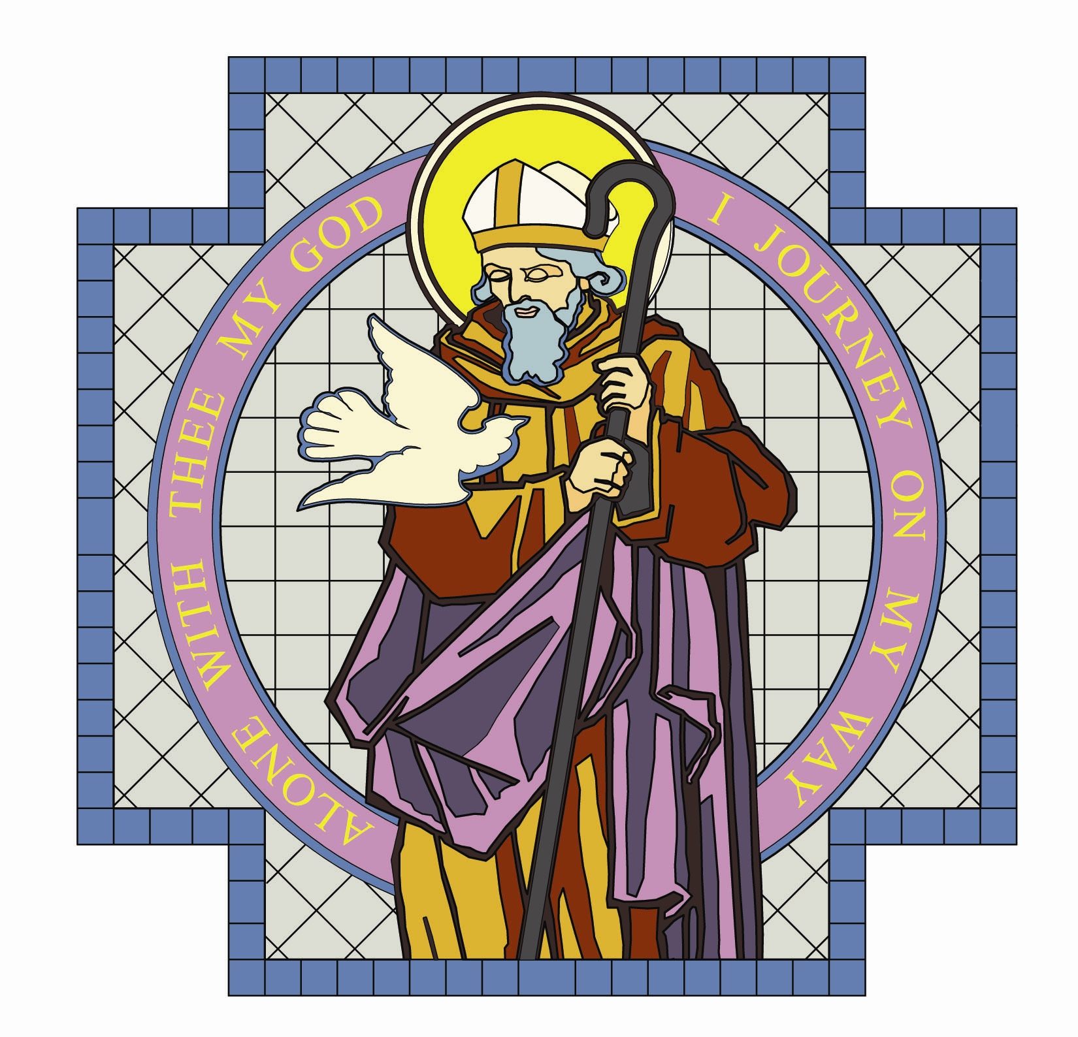

PARISH OF ST. COLMCILLE

BALLYHACKAMORE

SUNDAY BULLETIN
VOL. 24 NO. 35 24th July 2016

Fr. Ciaran Feeney Adm. 191 Upper Newtownards Road, Belfast, BT4 3JB.

Phone - 028 9065 4157. Website: www.st-colmcilles.net

E-mail - stcolmcilles@downandconnor.org
St. Joseph’s Primary School - www.stjosephsps.co.uk Phone – 9065 0039
St Colmcille’s Pre School - www.stcolmcilles-preschool.co.uk. Phone – 9047 2724

SEVENTEENTH SUNDAY IN ORDINARY TIME (Page 896, 452, 499)
17th week in Ordinary Time
Readings : Sunday Cycle C, Weekday Cycle 2, Psalter Week 1
Entrance Antiphon | (Psalm 67:6-7. 36) God is in his holy place, God who unites those who dwell in his house; he himself gives might and strength to his people.
1st Reading | (Genesis 18:20-32) I trust my Lord will not be angry, but give me leave to  speak.
Psalm | (Psalm 137) On the day I called, you answered me, O Lord.
2nd Reading | (Colossians 2:12-14) He brought you to life with him, he has forgiven us all our sins.
Acclamation | Alleluia, alleluia! The Word was made flesh and lived among us; to all  who did accept him he gave power to become children of God. Alleluia!
Gospel | (Luke 11:1-13) Ask and it will be given to you.
Children | Jesus is praying. One of his disciples asks if he will teach them to pray too. Jesus teaches his friends a very special prayer. He tells them to call God ‘‘Father’’ and ask him for what they need.
Communion Antiphon | (Psalm 102:2) Bless the Lord, O my soul, and never forget all his benefits.

SUMMER MASS TIMES
Saturday 6.30pm  Frances McClure | Sunday 11.00am  Owen Quigley
There will be no weekday Masses during the month of July.
Please see flyer for details of Mass times in other Churches, available in the Church Porch.

DECEASED
We pray for the repose of the soul of those who have died recently.
We remember all those whose anniversaries occur at this time of year especially:
Martin Rosaupan, Patricia O’Neill, Margaret Ganney, Brian Mallaghan, Kitty Clarke, Frances McClure and Owen Quigley.

BEREAVEMENT SUPPORT - we can be contacted on 074 5698 9458.
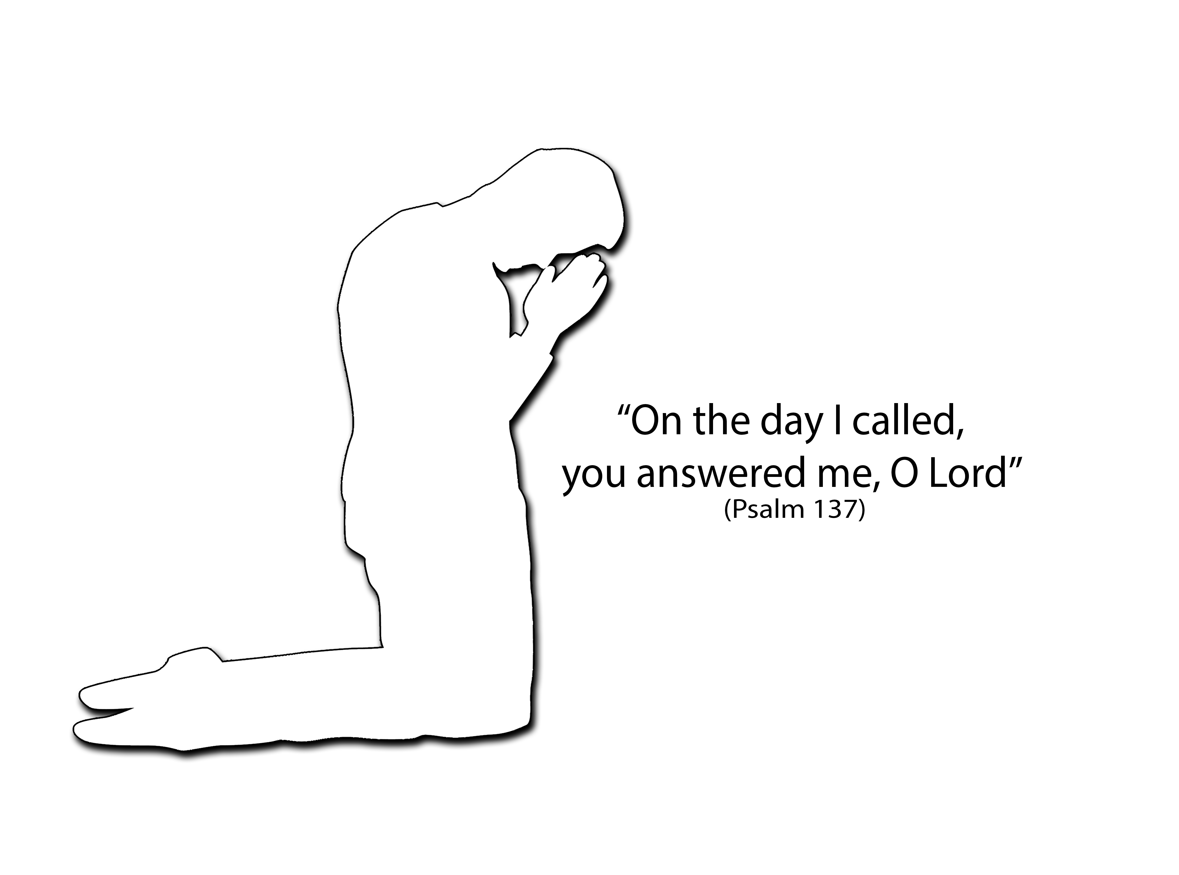


ADORATION OF THE BLESSED SACRAMENT

Monday and Tuesday from 2.00pm to 9.00pm

in the Chapel of Adoration.

Entrance is from the outside door at the left side of the Church.

EUCHARISTIC ADORATION is:
- Putting faith into action.
- Authentic witness of our belief in the Real Presence of Jesus in the Blessed Sacrament
- A practical way of giving God adoration.
- To show gratitude to Our Lord Jesus for our redemption.
- Petitioning God for the needs of the parish and its people!
ADORATION- More Volunteers are required on Mondays and Tuesdays to cover the hourly slots: 4.00pm-5.00pm; 5.00pm-6.00pm; 6.00pm-7.00pm. Volunteer slips are available at the back of the Church and completed ones can be left in the Bulletin box. Please consider giving an hour to Jesus in his Sacrament and receive the blessings that flow from this.
STANDBY LIST - If you cannot commit on a regular basis but are willing to be contacted to stand in for an Adorer from time to time please put your name and telephone number on the Standby List found in the Adoration Chapel and the back of the Church.
ROTA – It would be very much appreciated if you could kindly find a family member or friend to cover your hour when you are not available to come to Adoration.
CHAPEL OF ADORATION - Those who still wish to contribute to setting up this Chapel of Adoration may do so. Envelopes and slips can be found on the table at the back of the Church and returned to the parish office or placed in the Offertory collection baskets.

‘‘Indeed this is the will of my Father, that everyone who looks upon the Son and believes in him, shall have eternal life and I will raise him up on the last day"
(John 6: 40)

BAPTISM

The next Baptismal Course takes place on Tuesday 16th August in the Iona Room, Parochial Hall from 8.00pm to 9.30pm. Please contact the Parish Office to register attendance or make enquiries.

PARISH OFFICE
The office is open Monday to Thursday 10.00am-12.30pm and Friday 10.00am-1.00pm

MONEY MATTERS
WEEKLY OFFERING - Cash Collection £1464.55
THE PASTORAL SERVICES - Collection stands at £772.13
Many thanks to all who contributed so generously to the collections.

SUMMER EVENTS
IRISH DANCE SUMMER SCHEME – from Monday 1st to Friday 5th August in St. Colmcille's Parochial Hall from 9.45am to 12.30pm. Fun week of Irish dance for all, both experienced and beginner Irish Dancers welcome. Cost £55 per week. To book a place or enquire contact Nicola Oakes on Leonardnicola@hotmail.com or 077 1892 7242.
YOUTH PROGRAMME – Going For Gold: Monday 8th – Friday 12th August (fully booked); Lisburn Leisureplex: Monday 15th August; Tayto Park: Wednesday 17th August; Vertigo Trampoline Park: Friday 19th August. Enquries to Noeleen 078 7949 8131/ colmcilleyouth@yahoo.co.uk. Forms available in Church Porch.
LEADERSHIP PROGRAMME - running alongside the children’s Going For Gold scheme there will be a leadership training programme for young people aged 14 – 18 years. Additional adult volunteers over 18 years of age are also needed for Going For Gold. Please consider helping on some or all of the dates on the mornings of: Monday 8th- Friday 12th August. Please contact Noeleen on 078 7949 8131/colmcilleyouth@yahoo.co.uk

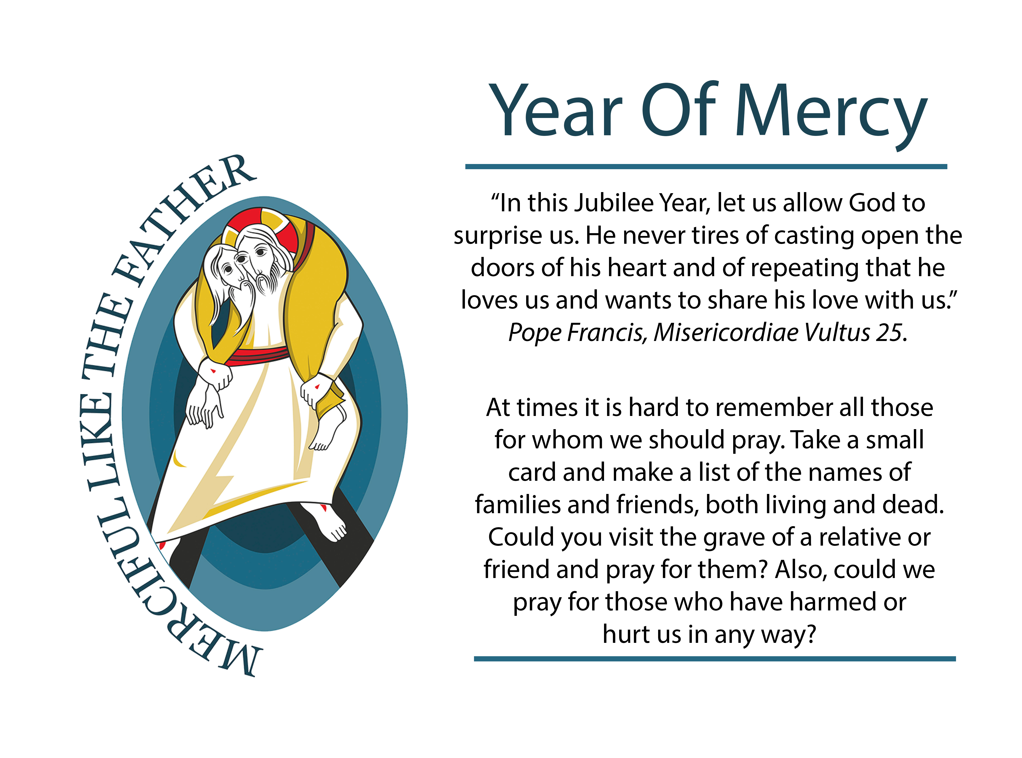

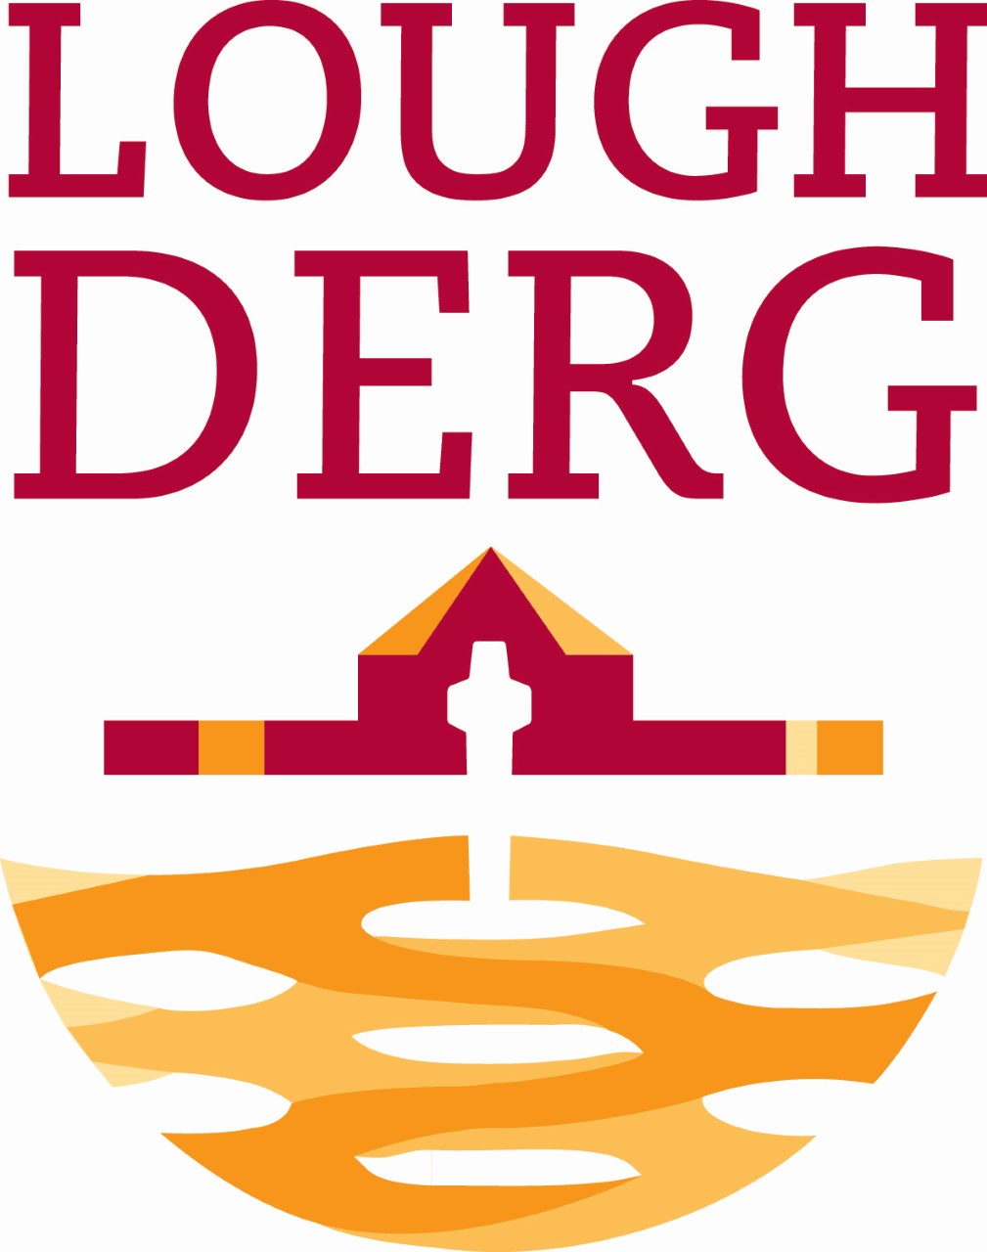
LOUGH DERG
Holy Year of Mercy on Lough Derg
Down and Connor One Day Retreat
Wednesday, 24th August 2016
Arrival 10.00am - Departure 4.15pm.
Cost: approximately £50.
A bus will be organised from this area to travel to Lough Derg – more details regarding Contact Person and pick-up point next week.

