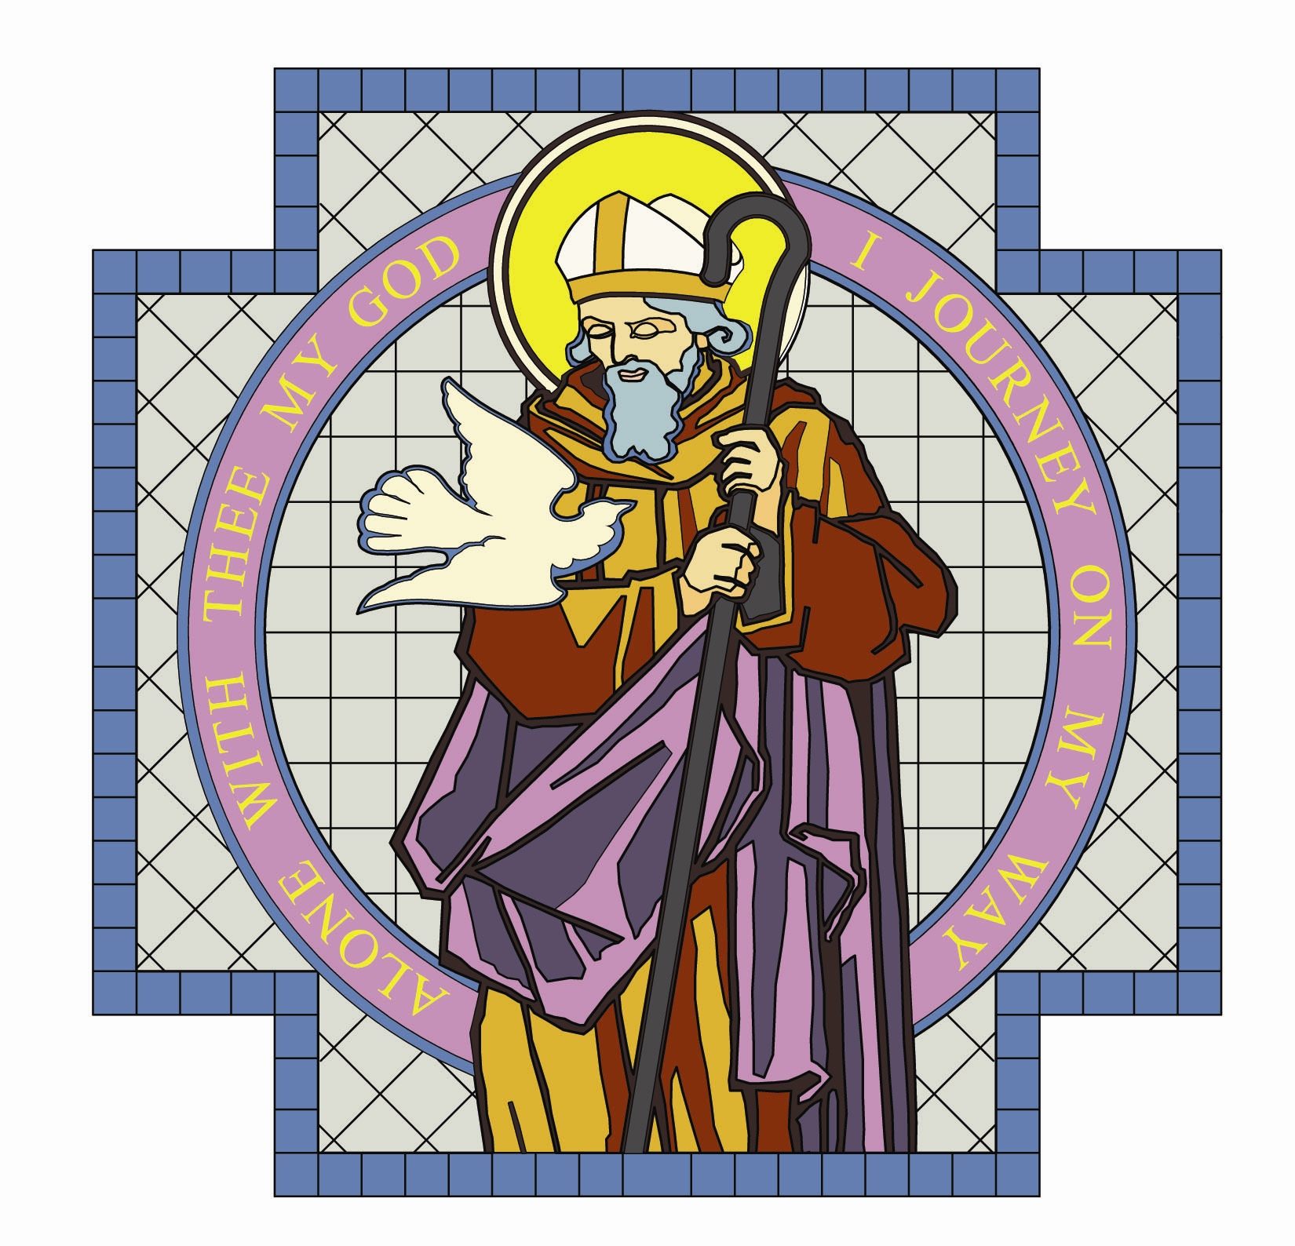

PARISH OF ST. COLMCILLE

BALLYHACKAMORE

SUNDAY BULLETIN
VOL. 24 NO. 39 14th Aug 2016

Fr. Ciaran Feeney Adm. 191 Upper Newtownards Road, Belfast, BT4 3JB.

Phone - 028 9065 4157. Website: www.st-colmcilles.net

E-mail - stcolmcilles@downandconnor.org
St. Joseph’s Primary School - www.stjosephsps.co.uk Phone – 9065 0039
St Colmcille’s Pre School - www.stcolmcilles-preschool.co.uk. Phone – 9047 2724
TWENTIETH SUNDAY IN ORDINARY TIME (Page 911, 452, 499)
20th week in Ordinary Time
Readings : Sunday Cycle C, Weekday Cycle 2, Psalter Week 4
Entrance Antiphon | (Psalm 83:10-11) Turn your eyes, O God, our shield; and look on the face of your anointed one; one day within your courts is better than a thousand elsewhere.
1st Reading | (Jeremiah 38:4-6, 8-10) You have borne me to be a man of dissension for  all the land.
Psalm | (Psalm 39) Lord, come to my aid!
2nd Reading | (Hebrews 12:1-4) We shall keep running steadily in the race we have started.
Acclamation | Alleluia, alleluia! Open our heart, O Lord, to accept the  words of your Son. Alleluia!
Gospel | (Luke 12:49-53) I am not here to bring peace, but rather division.
Children | Mary says ‘‘yes’’ to helping God in a very special way. She is going to have a baby because God has chosen her to be Jesus’ loving mother. Mary knows that her cousin Elizabeth is also having a baby and goes to visit her. When Mary arrives, Elizabeth feels that her baby is very excited. Mary and Elizabeth are so happy because they know that God is at work in all the amazing things that are happening to them. They pray together, thanking God for the good news about their babies and look forward to them being born.
Communion Antiphon | (Psalm 147:12, 14) With the Lord there is mercy; in him is plentiful redemption.

SUMMER MASS TIMES
Saturday | Sunday | Monday | Tuesday | Wednesday | Thursday | Friday
6.30pm | 11:00am | 9.30am | 9.30am | 9.30am | 9.30am  Communion Service | 9.30am  Anointing  of the sick
Confessions 6.00pm |  | 7.00pm

Monday- Assumption of the Blessed Virgin Mary

ADORATION OF THE BLESSED SACRAMENT

Monday and Tuesday from 2.00pm to 9.00pm

DECEASED
We remember all those whose anniversaries occur at this time of year especially:
Claire Higgins and Noel McGivern
BEREAVEMENT SUPPORT - we can be contacted on 074 5698 9458.

BAPTISM
We welcome Thomas Eugene Conlon, who has been recently baptised, to our Parish family.

The next Baptismal Course takes place on Tuesday 16th August in the Iona Room, Parochial Hall from 8.00pm to 9.30pm. Please contact the Parish Office to register attendance or make enquiries.

YOUTH EVENTS
•Lisburn Leisureplex : Monday 15th August, meet 1.00pm in car park, return 5.30pm.
•Tayto Park, Co Meath : Wednesday 17th August, meet 9.00am in car park, return 6.30pm
•Vertigo Trampoline Park : Friday 19th August, meet 6.00pm in car park, return 8.30pm
Forms available in Church Porch. Enquries to Noeleen 07879 498131/ colmcilleyouth@yahoo.co.uk.
GOING FOR GOLD Many thanks to all of the amazing 56 parish volunteers, including 30 teenagers, who delivered a programme of activities to 116 children aged 4 – 8 years, in the Going For Gold children’s holiday bible week - which was based on the story of David and Goliath in the Old Testament and an Olympics sporting theme. Among the many important messages they were given, the children learned that - God has a special plan for each one of them; though they are young they are important; God can give us protection, strength and courage when we trust in him; don’t be fearful of bullies, you have plenty of support behind you; always try your best; face challenges with God’s help; everyone has special talents. The leaders reinforced the key themes and messages through games, crafts, singing and musical fitness activities. A special thanks also to our main sponsors – Millar, Mc Call & Wylie, Solicitors, Ballyhackamore and Tesco’s Local.

MONEY MATTERS
WEEKLY OFFERING - Collection - £1725.82
Many thanks to all who contributed so generously to the collection.
Diocesan Care Homes Collection will be taken up at all Masses next weeken

