ADORATION OF THE BLESSED SACRAMENT

Monday and Tuesday from 2.00pm to 9.00pm

DECEASED
We pray for the repose of the souls of all those who have died recently,
especially Paul Judge.
We remember all those whose anniversaries occur at this time of year, especially:
Mary Fusco and Josephine Judge
BEREAVEMENT SUPPORT - we can be contacted on 074 5698 9458.

BAPTISM

The next Baptismal Course takes place on Tuesday 20th September in the Iona Room, Parochial Hall from 8.00pm to 9.30pm. Please contact the Parish Office to register attendance or make enquiries.

YOUTH EVENTS
GOING FOR GOLD Many thanks to all of the amazing 56 parish volunteers, including 30 teenagers, who delivered a programme of activities to 116 children aged 4 – 8 years, in the Going For Gold children’s holiday bible week - which was based on the story of David and Goliath in the Old Testament and an Olympics sporting theme. Among the many important messages they were given, the children learned that - God has a special plan for each one of them; though they are young they are important; God can give us protection, strength and courage when we trust in him; don’t be fearful of bullies, you have plenty of support behind you; always try your best; face challenges with God’s help; everyone has special talents. The leaders reinforced the key themes and messages through games, crafts, singing and musical fitness activities. A special thanks also to our main sponsors – Millar, Mc Call & Wylie, Solicitors, Ballyhackamore and Tesco’s Local.

MONEY MATTERS
WEEKLY OFFERING - Collection - £1510.56
FEAST OF THE ASSUMPTION COLLECTION £415.19
Many thanks to all who contributed so generously to the collection.
The Diocesan Care Homes Collection will be taken up at all Masses this weekend

SUICIDE AWARENESS TRAINING - 318 deaths by accident in 2015- the highest number since records began in 1970. A training day on suicide awareness will be given by Philip McTaggart of Mindskills Training in Tobar Mhuire Retreat House on Saturday 10th September from 10am until 3pm. Cost: £30 per person (incl. tea/coffee and lunch). Early booking essential due to limited places. Contact: secretary@tobarmhuirecrossgar.com .
Tel.: 02844830242

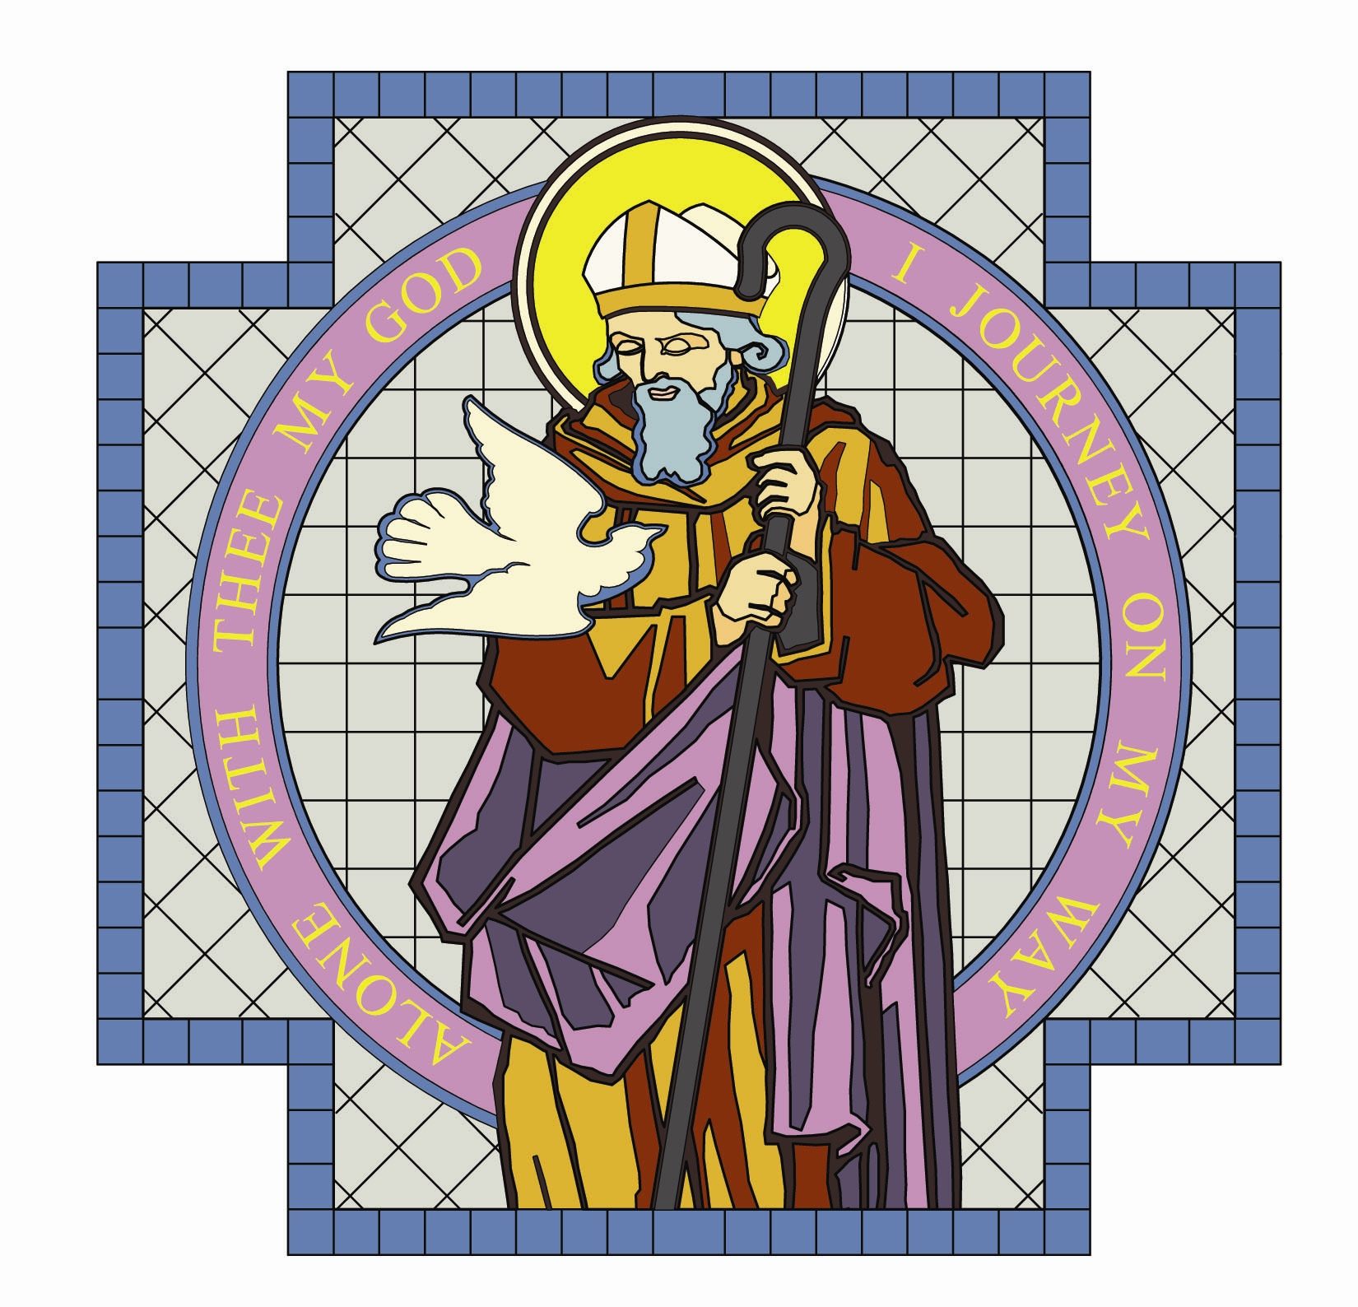

PARISH OF ST. COLMCILLE

BALLYHACKAMORE

SUNDAY BULLETIN
VOL. 24 NO. 40 21st Aug 2016

Fr. Ciaran Feeney Adm. 191 Upper Newtownards Road, Belfast, BT4 3JB.

Phone - 028 9065 4157. Website: www.st-colmcilles.net

E-mail - stcolmcilles@downandconnor.org
St. Joseph’s Primary School - www.stjosephsps.co.uk Phone – 9065 0039
St Colmcille’s Pre School - www.stcolmcilles-preschool.co.uk. Phone – 9047 2724
TWENTY-FIRST SUNDAY IN ORDINARY TIME (Page 915, 452, 499)
21st week in Ordinary Time
Readings : Sunday Cycle C, Weekday Cycle 2, Psalter Week 1
Entrance Antiphon | (Psalm 85:1-3) Turn your ear, O Lord, and answer me;  Save the servent who trusts in you, my God. Have mercy on me, O Lord, for I cry to you all the day long.
1st Reading | (Isaiah 66:18-21) They will bring all your brothers from all the  nations.
Psalm | (Psalm 116) Go out to the whole world; proclaim the Good News.
2nd Reading | (Hebrews 12:5-7. 11-13) The Lord trains the one that he loves.
Acclamation | Alleluia, alleluia! If anyone loves me he will keep my word,  and my Father will love him, and we shall come to him. Alleluia.
Gospel | (Luke 13:22-30) Men from east and west will come to take their  places at the feast in the kingdom of God.
Children | Jesus says we will get to God our Father through a narrow door! The way to God is not always easy. We will find our way to God if we follow Jesus’ example and love other people. Jesus tells us today that we must put other people before ourselves. Those who put themseleves last will be put frst by God.
Communion Antiphon | (Psalm 103:13-15) The earth is replete with the fruits of your work, O Lord; you bring forth bread from the earth and wine to cheer the heart.

SUMMER MASS TIMES
Saturday | Sunday | Monday | Tuesday | Wednesday | Thursday | Friday
6.30pm | 11:00am |  | 9.30am | 9.30am | 9.30am | 9.30am  Anointing  of the sick
Confessions 6.00pm

