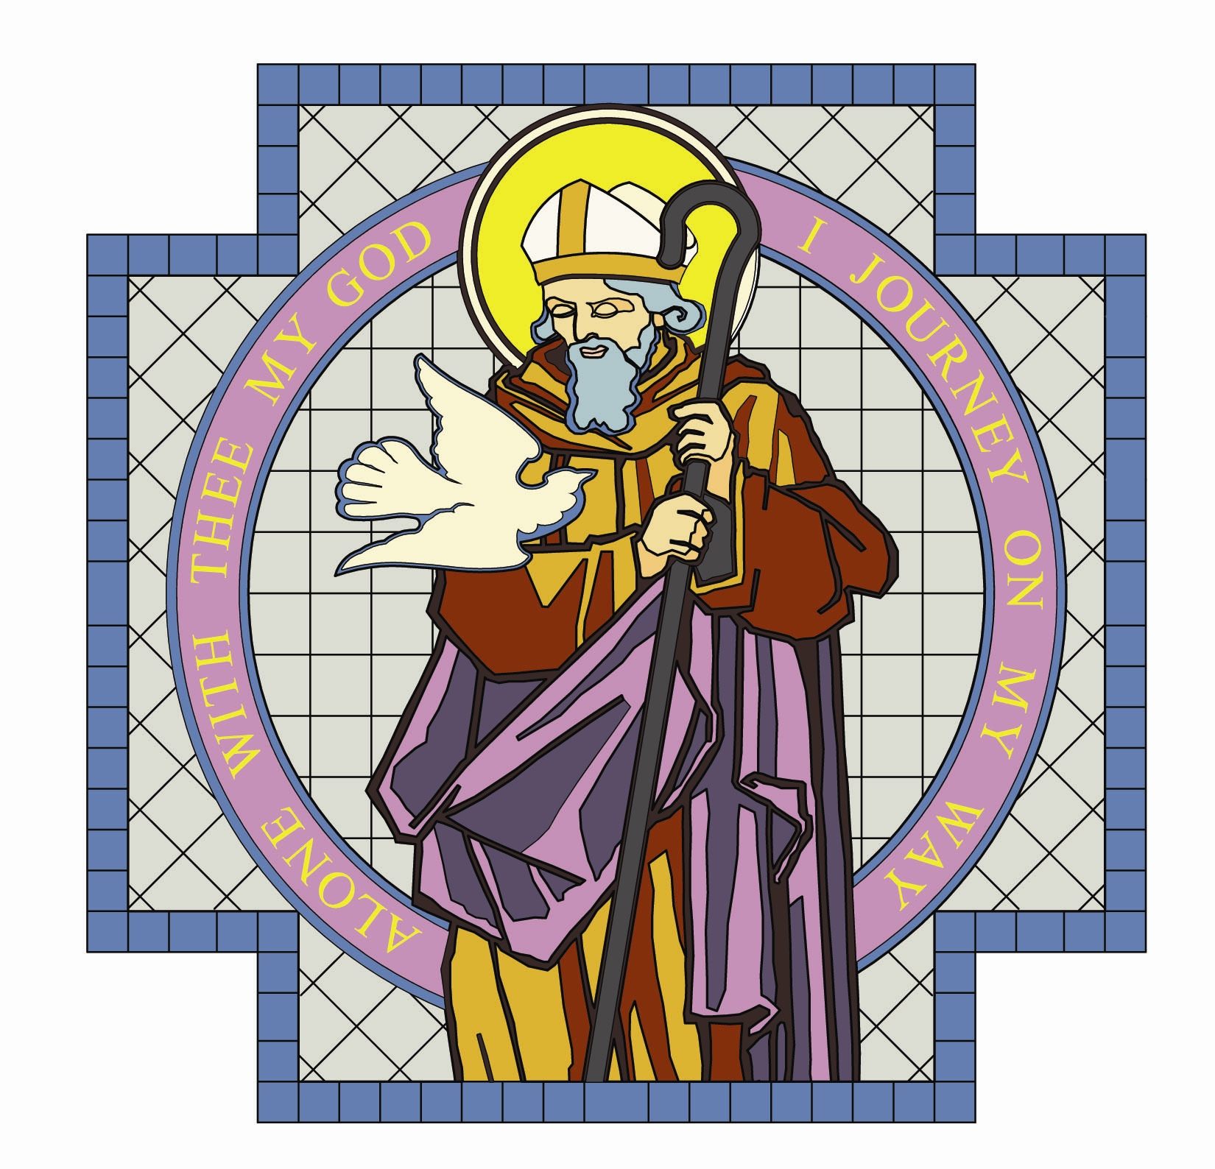

PARISH OF ST. COLMCILLE

BALLYHACKAMORE

SUNDAY BULLETIN
VOL. 31 NO. 55 4th December 2016

Fr. Ciaran Feeney Adm. 191 Upper Newtownards Road, Belfast, BT4 3JB.

Phone - 028 9065 4157. Website: www.st-colmcilles.net

E-mail - stcolmcilles@downandconnor.org

SECOND SUNDAY OF ADVENT - A (Page 5, 452, 490)
2nd Week in Advent
Readings : Sunday Cycle A, Psalter Week 2

Entrance Antiphon | O people of Sion, behold, the Lord will come to save the nations, and the Lord will make the glory of his voice heard in the joy of your heart
1st Reading | He judges the wretched with integrity  Isaiah 11:1-10
Psalm | In his days justice shall flourish and peace till the moon fails.  Psalm 71
2nd Reading | Christ is the saviour of all men.  Romans 15:4-9
Acclamation | Alleluia, alleluia! Prepare a way for the Lord, make his paths straight, and all mankind shall see the salvation of God. Alleluia!
Gospel | Repent, for the kingdom of heaven is close at hand.  Matthew 3:1-12
Children | John the Baptist said that he was getting ready for someone great. John baptised Jesus in the river. As Jesus came out of the water the Spirit of God came down, like a dove, and God’s voice said he was very pleased with his son, Jesus
Communion Antiphon | Jerusalem, arise and stand upon the heights, and behold the joy which comes to you from God.

MASS TIMES

Saturday | Sunday | Tuesday | Wednesday | Thursday | Friday
6.30pm  Geraldine Woollams | 9.30am | 9.30am  Claire Regan | 9.30am  Vigil Mass  7.00pm | Feast of the Immaculate Conception  9.30am  Lily Rice | 9.30am  Anointing of the sick
Confessions 6.00pm | 11.30am
Feast of Immaculate Conception Vigil Mass will be held on
Wednesday 7th December at 7.00pm

DECEASED

We pray for the repose of the souls of those who have died recently especially Paul Close. We remember all those whose anniversaries occur at this time of year especially: Geraldine Woollams,
Claire Regan, Lily Rice, Bernadette Kane, John Coulter,
Annie Coulter and James Forrester.

BEREAVEMENT SUPPORT - we can be contacted on
07456 989458

CHRISTMAS IN ST COLMCILLE’S

WALK WITH ME
A journey of Prayer for Advent and Christmas. Copies are available at the back of the church. Price £1. Please put money in any of the Candelabra boxes.

MINISTRY OF OUTREACH – please collect your pack for delivery in the porch after all Masses this weekend. If anyone would like to volunteer to help in distributing outreach envelopes please contact the Parish office.

TAP CHRISTMAS GIFT CARDS
Give a really worthwhile Christmas present this year - a Christmas Gift Card to support our twinned parish of Moita Bwawani in our Tanzanian Africa Project. Choose from 3 life-changing themes. Buy a year’s School Uniform for a Masaai Child for £10. Sponsor a Catechist to spread the Word of God, also for £10. Give pre-natal and ante-natal care to Masaai mothers-to-be and with our Mobile Medical Clinic Appeal for £20. Cards on sale in the church porch this weekend and each weekend up to Christmas.

ST COLMCILLE’S ADVENT SERVICE
Everyone is invited to participate in the annual Advent Service led by our choir and the primary school choir at 6.00pm on Sunday 11th December 2016. Refreshments afterwards in the church hall.

PENITENTIAL SERVICE
The Penitential Service will be held on Sunday 18th December at 3.00pm.

BAMBINELLI SUNDAY
For several decades, an Italian tradition, has been to bring a Christ-child figure to St Peter’s Square, to be blessed by the Pope on a Sunday in Advent. As part of our Advent celebrations, all children and adults are invited to bring their Christ-child figure from home, to be blessed at the 9.30am Mass at St Colmcille’s on Sunday 20th December. A suggestion is, following the blessing, take your ‘bambinelli’ home and place it in a gift box, wrap it, and save it for Christmas. Let this be the first gift your family opens on Christmas, when together you place the Christ-child figure in your Crib.


ADORATION OF THE BLESSED SACRAMENT

Monday and Tuesday from 2.00 pm to 9.00 pm

in the Chapel of Adoration.

WEEKLY OFFERING

Weekly Offering Cash Collection and Standing Orders: £

Many thanks to all who contributed so generously to the collection.
The Monthly Stipend Collection will be taken up at all Masses this weekend

BAPTISMS


We joyfully welcome into the Parish Family

Alexander Francis Murray Hart, Molly Grace Stevenson,
Hala Rose Smyth, Edith Lena Smyth, Sarah Annie Smyth.

who were Baptised in St Colmcille’s recently.

PARISH OFFICE

The Parish Office will be closed this Monday 5th December 2016.

UNLOCKING THE MYSTERY OF THE BIBLE

This programme is presented by Jeff Cavins on DVD. His dynamic teaching in conjunction with thought provoking discussion questions, will open the door to you, to a new found understanding of God’s word.

The programme continues on Wednesday evenings, 7.30pm – 9.00pm, in the Parochial Hall and is repeated there on Friday mornings, 10.00am – 11.30am. Everyone is welcome.

Dates for your diary:

Wednesday evening: 7th December, 11th, 18th, 25th January; 1st February.

Friday morning: 9th December, 13th, 20th, 27th January; 3rd February.

OTHER EVENTS

CHRISTMAS OUTREACH
Ministers of Outreach will be starting to visit every home in the Parish this coming week with a pack containing a Christmas Card from Father Ciaran detailing the times of Christmas services and the 3rd edition of St Colmcille’s Causerie. We currently need another 13 people to ensure every home in the Parish is visited with this year’s Christmas material. If you can help the Parish by delivering in any of the following areas, please speak to Philomena in the porch after Mass: Mawhinney Park/Comber Road; Old Mill/Coopers Mill; Cairnburn area/Tweskard area; Upper Newtownards Road around Stormont; Circular Road; Carolhill Park area; Holywood Road (Arches side); Summerhill Avenue, Elsmere/Moyne Park; Glenview Avenue/Castlehill Farm; Martinez Avenue or Bloomfield Road area.

APOSTOLIC WORK CHRISTMAS SALE
Thank you to all who, in any way, supported our event last weekend by donating or buying, by setting out the furniture, by putting it away afterwards or by helping on stalls and in the kitchen. Thanks to your generosity we raised £3,469 for use on the Missions. Be assured it will make a huge difference to many people.

ST VINCENT DE PAUL
We would like to thank our 30 volunteers who stood out in the cold at local shops collecting £1,714.25, badly needed funds in the light of the many requests from persons in our area, which stretches from Connswater to Ballybeen and from Sydenham to the Castlereagh Road. In particular, we would like to thank Marks & Spencer, Spar and Tesco Express shops at Ballyhackamore and SuperValu King’s Square for giving us permission to collect outside their stores and many thanks to their customers for their great generosity.

APOSTOLIC WORK MONTHLY MEETING
The next meeting of the Apostolic Work is on Tuesday 6th December 2016 at 8.00pm in the Iona Room.

ARTISAN MARKET AND FAMILY FUN DAY
This will be held in the Church Grounds on Saturday 10th December from 10.00am to 4.00pm. There will also be more stalls available and Santa will be in attendance as well.

WEDNESDAY CHRISTMAS CLUB
The Wednesday Club Christmas 2 course lunch at La Mon Hotel on Wednesday 14th December. Music and entertainment provided. If you would like to join us please ring Anna on 028 9065 1351 before Wednesday 7th December. Bus will be leaving the carpark at 1.00pm sharp.

AN EVENING OF FESTIVE FAVOURITES AT DRUMALIS
Friday 16 December 2016 - The evening will include seasonal favourites, old and new, performed by Voices Chamber Choir under the direction of Loreto McAuley. On arrival, there will be a festive reception with entertainment commencing at 7.30 pm. A two-course supper will be served during the interval. The cost for the evening is £25 per person and admission is by pre-paid ticket only. For further information, please contact Drumalis during office hours (Monday – Friday, 9.00am to 5.00pm) – telephone 028 2827 2196/028 2827 6455.

