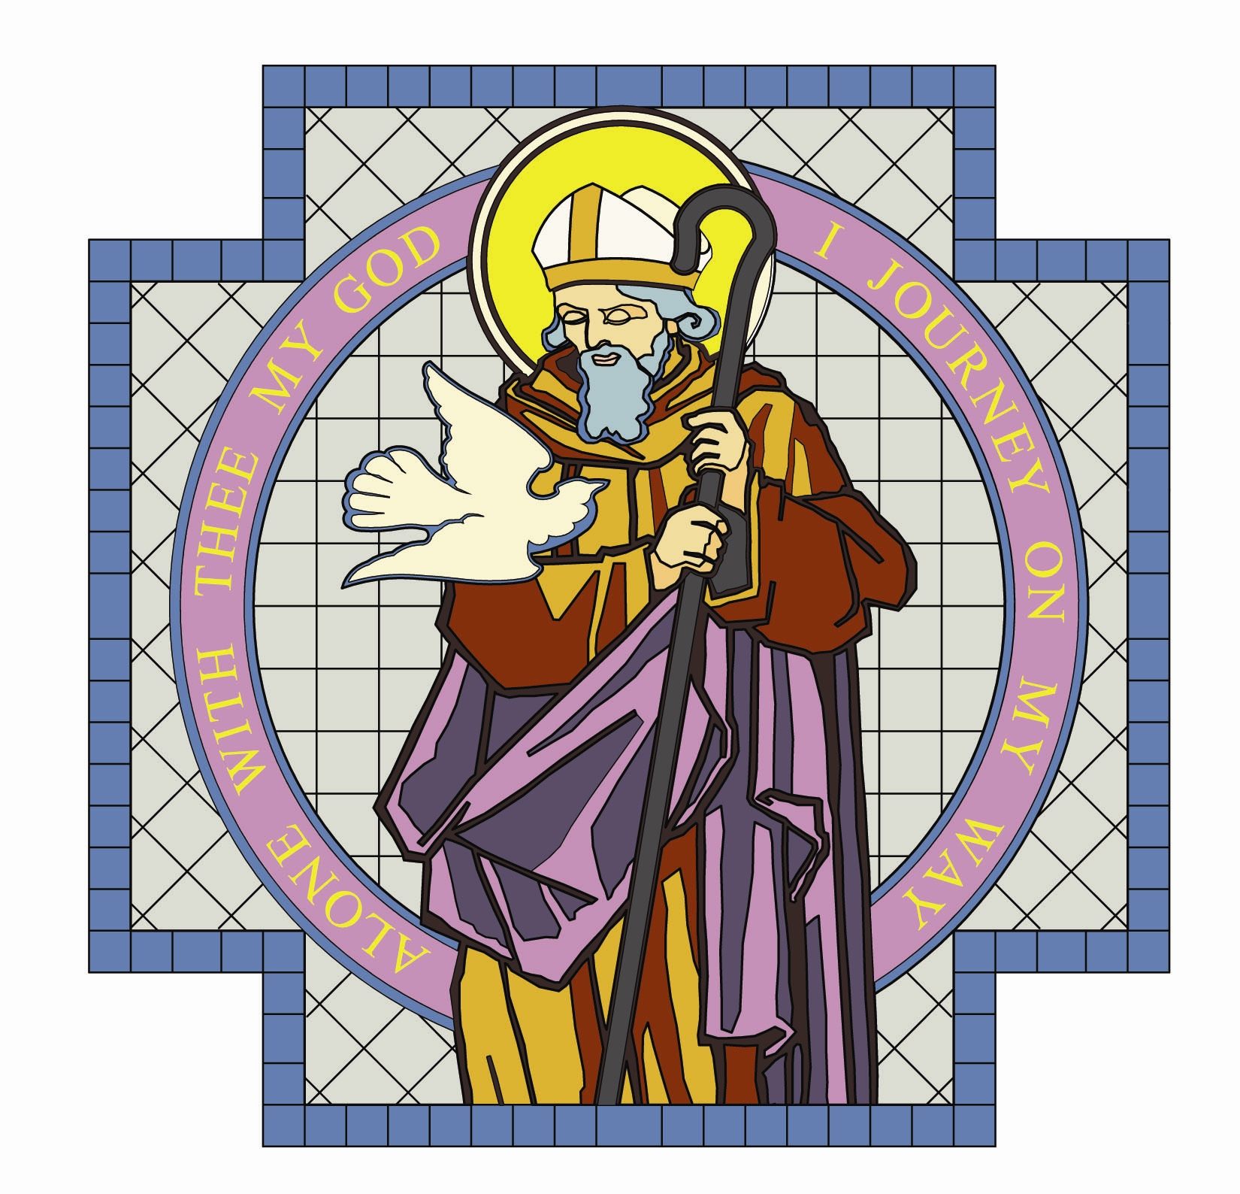

PARISH OF ST. COLMCILLE

BALLYHACKAMORE

SUNDAY BULLETIN
29th January 2017

Fr. Ciaran Feeney Adm. 191 Upper Newtownards Road, Belfast, BT4 3JB.

Phone - 028 9065 4157. Website: www.st-colmcilles.net

E-mail - stcolmcilles@downandconnor.org
FOURTH SUNDAY IN ORDINARY TIME
(Page 568, 452, 500)
4th week in Ordinary Time
Readings : Sunday Cycle A, Weekday Cycle 1, Psalter Week 4

Entrance Antiphon | Save us, O Lord our God! And gather us from the nations, to give thanks to your holy name, and make it our glory to praise you.
1st Reading | In your midst I will leave a humble and lowly people.  Zephaniah 2:3; 3:12-13
Psalm | How happy are the poor in spirit; theirs is the kingdom of  heaven. Psalm 145
2nd Reading | God chose what is foolish by human reckoning.  1 Cor 1: 26-31
Acclamation | Alleluia, alleluia! Blessed are you Father, Lord of heaven and earth, for revealing the mysteries of the kingdom to mere children. Alleluia!
Gospel | How happy are the poor in spirit.  Matthew 5: 1-12
Children | Jesus teaches some surprising things about how to be happy. He says that blessed are the poor, the sad, and those who really care that everything is fair for everyone.
Communion Antiphon | Let your face shine on your servant. Save me in your merciful love. O Lord, let me never be put to shame, for I call on you.

MASS TIMES

Saturday | Sunday | Tuesday | Wednesday | Thursday | Friday
6.30pm  Confessions  6.00pm | 11.30am  Claire Knox  William Knox  Laura McDowell  Patrick Morris  Noel O’ Hare | 9.30am  John Doyle | 9.30am  Annie Price  Catholic Schools’ Week  Mass | 9.30am | 9.30am  Anointing of the sick
Sunday 9.30am
Ethna Sheppard

Fr. Ciaran will attend the sick and housebound this week.

DECEASED

We pray for the repose of the souls of all those who have died recently, especially Peter Donnelly, John Mateer, Dessie Mc Auley,
Martha Quirk, Ethna Sheppard.
We also remember all those whose anniversaries
occur at this time of year especially:
John Clark, Mary Clark, John Doyle, Marcelino Dumalagan,
Molly Gibson, Claire Knox, William Knox, Laura McDowell,
Patrick Morris, Noel O’Hare, Annie Price

BEREAVEMENT SUPPORT - we can be contacted on
07456 989458

FAITH MATTERS
ST. BRIGID'S DAY St Brigid’s feast day is this Wednesday 1st February. St Brigid’s crosses will be available after the Masses this weekend. Suggested donation is £1. All proceeds go to third world charities. St Brigid’s parish will have their annual St Brigid’s Day talk, given by His Eminence Cardinal Vincent Nichols Archbishop of Westminster, on “Significant Aspects of The Jubilee of Mercy” in St. Brigid's Church next Tuesday 7th February at 7.30pm Everyone welcome.

BETHANY BEREAVEMENT SUPPORT
Bethany Bereavement Support is offered on an individual basis in the home, to groups in drop-in centres, by phone calls, by helping at funeral liturgies and remembrance services. A full training course is offered over a 10 evening period. For more information or to register interest in the next Training Course which begins in March 2017 and will take place in the Good Shepherd Centre, please contact the parish office or Claire Dowds, Good Shepherd Centre, 511 Ormeau Road, Belfast BT7 3GS.
 07557882183, email: bethanybereavementni@gmail.com

DIOCESAN PILGRIMAGE TO LOURDES 2017
Full board in 4* hotel: 7 nights, 10th – 17th July, for £675 or 5 nights,
11th – 16th July, for £590. Full board for sick or infirm pilgrims with nursing care in Accueil Notre-Dame: 5 nights, 11th - 16th July for £490.
Youth team: 8th – 17th July, £500. All flights from Belfast International. Further information contact the Pilgrimage Office on 029890 646040

MONEY MATTERS
Weekly Offering Cash Collection and Standing Orders : £1,847.67
The Monthly Stipend Collection will be taken up at all Masses next
weekend. Many thanks to all who contributed so generously to the collection last weekend.

ADORATION OF THE BLESSED SACRAMENT

Monday and Tuesday from 2.00pm to 9.00pm

in the Chapel of Adoration.
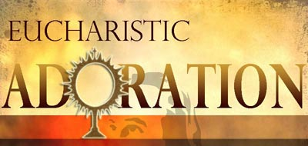

Six reasons for spending a Holy Hour before the Blessed Sacrament:

- This is a personal invitation to YOU from JESUS

- Day and night JESUS dwells in the Blessed Sacrament because YOU are the most important person in the world to HIM!

- YOU grow spiritually with each moment you spend with JESUS!

- The best time YOU spend on earth is with JESUS, your Best Friend, in the Blessed Sacrament

- With transforming mercy, JESUS makes YOUR HEART one with his

- JESUS in the Blessed Sacrament sends out to YOU divine rays of his grace, love and peace

Can YOU commit to spend one hour with JESUS especially between 4.00pm – 5.00pm or 5.00pm - 6.00pm on Mondays or Tuesdays?

If so write your name in the register in the Chapel of Adoration or leave a message with the Parish Office between 10.00am – 12.00noon. Of course everyone is free to visit JESUS exposed in the Chapel of Adoration when they wish.


ST COLMCILLE’S PARISH DRAW

Don’t worry if you feel you have missed out last year… this year’s Parish Draw is being launched -
this Saturday 28th January & Sunday 29th January.

Committee members will be at the back of the Church, on this Saturday night and on this Sunday, after all the Masses. There will be free Tea & Coffee available in the Parochial Hall.

Please show your support to the Parish by purchasing a ticket or two!

Any queries please contact - Roisin McMullan on 07854 140019,
Lucy Traynor on 07900 807589 or Mary Walsh on 07815 493463.

4 CORNERS FESTIVAL

Play : Derek and Dave – In Search of a Bench
Derek and Dave are out for their usual walk around the park but this time something’s different; Jesus has just made his triumphant entry into Belfast, rather than Jerusalem, with a huge crowd gathered and now the place is a mess! As they journey through the park looking for a decent spot to sit, they observe, pass judgement and allow us to catch a glimpse of the wounded and wonderful.

The 4 Corners festival seeks to introduce people to churches in the four corners of the city, bringing a transformational energy to the healing of the city. This year’s theme is “Our Wounded and Wonderful City”, and we hope you can join us and together find healing for our wounds.

Next Saturday 4th February at 8.00pm, in St Colmcille’s Parochial Hall. Admission Free.

EVENTS

CATHOLIC SCHOOLS’ WEEK
Catholic Schools’ Week starts this Sunday 29th January. This year’s theme is ‘learning with Pope Francis to care for our common home’. The Church reminds us that we have a duty of care to the world and all in it. A special Mass will be celebrated this Wednesday 1st February at 9.30am.

As part of Catholic Schools’ Week, there will be a Grandparents Day in St Joseph’s Primary School, on this Tuesday 31st January, where all grandparents are invited to visit the school at 11.00am for refreshments in the school hall. This will be followed by an opportunity to walk around the school, visit the classes and help their grandchild with his/her work.

VOLUNTEERING
Always wanted to volunteer overseas? Looking for a course about global social injustice? Learn more at the Viatores Christi (VC) - Information & Recruitment Session in Belfast on this Tuesday 31st January at 7.30pm in St John's Parochial House, Falls Road, Belfast BT12 6EN
phone 0035318689986; email: apply@viatoreschristi.com
website: www.viatoreschristi.com …..for more information. All welcome!

ST AGNES' CHORAL SOCIETY
The Society is celebrating it's 60th Anniversary in The Ulster Hall with a concert: Music and Memories, on next Saturday 4th February at 7.30pm. Tickets can be purchased online at www.ulsterhall.co.uk or
028 9033 4455. The Society's chosen charity this year is Alzheimers NI.

PARISH OFFICE
The Parish Office will be closed this Monday 30th & Tuesday 31stJanuary.

