DECEASED

We pray for the repose of the souls of those who have died recently. We remember all those whose anniversaries occur at this time of year especially:
Terese Campbell, Don Conway, Ita O’Brien, James Slattery, Noel Holland, Peg O’Leary, Joanna Hawthorne, Christopher Robinson, Kitty Gibson, Sean McDermott
and Martin Nugent

BEREAVEMENT SUPPORT - we can be contacted on 07456 989458

NOVEMBER IS THE MONTH OF DEVOTION TO THE HOLY SOULS
During the month of November Mass will be celebrated each day for the repose of the souls of those deceased whose names have been included in the November Dead Lists.
Lists are available at the rear of the Church. If you wish to donate an offering for the Masses, please include it with the List in the envelope provided. Completed Lists can be placed in the collection baskets or in the box at the front of the Church.

The ANNUAL MASS FOR DECEASED PARISHIONERS will be held this Tuesday 15th November at 7.00pm.

PARISH ACTIVITIES

SCRIPTURE AND PRAYER GROUP
The next meeting will be this Tuesday 22nd November at 8.00pm in the Committee Room. Reflections will be on the readings for the Feast of Christ the King and secondly on First Sunday of Advent, Year A, St Matthew and some throughs on the Year of Mercy.

PARENTS MEETING
There will be a meeting for parents of the children who are being prepared for the Sacrament of Holy Communion on Tuesday 29th November at 7.00pm.

MINISTRY OF WELCOME
We have a great shortage of Ministers of Welcome and are asking for new Ministers.
It involves volunteering twice a year, undertaking to welcome Parishioners before 6.30pm Saturday Mass, or 9.30am or 11.30am Sunday Masses. Your role is to give each Parishioner a Missal and Bulletin and to particularly welcome new Parishioners.
If you are willing please put your name on the list at the back of the church.

THE LARDER
Every week The Larder distribute food, toiletries, bin bags, cleaning products, washing up liquid, Jay cloths and Brillo Pads to poor families in East Belfast. We as a Parish collect these items twice a year. So for the month of November we will have boxes at the back of the church to collect these items with the exception of baked beans and cereals of which they have an ample supply.

APOSTOLIC WORK CHRISTMAS SALE
Apostolic Work Christmas Sale will be held after all the Masses on 26th and 27th November, the first weekend of Advent. Tea, coffee and scones and all the usual stalls including a special Christmas stall. Please come to support the Missions. Cake and craft donations will be very welcome.


ADORATION OF THE BLESSED SACRAMENT

Monday and Tuesday from 2.00 pm to 9.00 pm

in the Chapel of Adoration.

WEEKLY OFFERING

Weekly Offering Cash Collection and Standing Orders: £

The Bishops Commission's Collection will be taken up at all Masses next
weekend.
Many thanks to all who contributed so generously to the collection.


BAPTISMS

We joyfully welcome into the Parish Family

Nellie Anne Collins, Charlie Campbell, Sadhbh Anna Banton,
Annie Méabh Toland and Tom James O’Brien.

who were Baptised in St Colmcille’s recently.

When arranging a Baptism please contact the Parish office to register attendance at the Baptism meeting. This will be held every third Tuesday of each month in the Iona Room. You may arrange the Baptism date at this meeting and complete the registration card. The next meeting will be held on Tuesday 15th November at 8.00pm.

If parents have already attended the meeting for an earlier Baptism please contact the Parish office to complete a registration card and arrange a Baptism date.

PARISH OFFICE

The Parish Office will be closed this Monday 14th November 2016

UNLOCKING THE MYSTERY OF THE BIBLE

In a follow up to Sean’s morning with us, the Living Faith Parish Group are providing you with an opportunity to explore the Bible further by proving the series “Unlocking the Mystery of the Bible” presented by Jeff Cavins. This will take place on 8 Wednesday evenings: 7.30pm – 9.00pm on 16th, 23rd, 30th November; 7th December and 11th, 18th, 25th January; 1st February.

You may sign up on the morning of 12th November or complete a slip that you will find
next to the Bulletin Box in the Church Porch. Please post in the Bulletin Box.

OTHER EVENTS

ST VINCENT DE PAUL CHRISTMAS CARDS
St Vinent De Paul Christmas cards will be on sale in the Church porch after all Masses this weekend. They are priced at £5.00 for packs of 12 assorted cards and £4.00 for packs of 10 of a single design.

NEW ALTAR SERVERS
Young people in Primary 6 and above are invited to join the Ministry of Altar Service. Training for those attending St Joseph’s Primary School begins this Wednesday 16th November at 3.10pm-4.00pm in the Church. For those not attending St Joseph’s School, training begins next Sunday 20th November at 10.20am-11.10pm. Enquiries to Noeleen 07879 498131.

WEDNESDAY CLUB
The Wednesday Club are going bowling at Dundonald this week Cars are leaving car park at 1.30pm. Names to Anna 028 9065 1351 please.

QUIZ NIGHT
St Vincent de Paul Quiz Night – this Friday 18th November 2016 at 8.00pm in St Colmcilles Church Hall. Brian and Siobhan Gilfedder are hosting a trivia fun quiz in aid of the St Vincent de Paul Christmas Appeal. Why not come and support a great cause and have a great night’s craic. £5.00 per head and no reasonable limit to team size.

LIFETIME OF CHANGE
The loss of a partner through death, separation or divorce is devastating. Beginning Experience is offering ‘a weekend away for a lifetime of change’ at Drumalis, Larne, 25th-27th November 2016.
To find out more, contact Phil: 02890 207645 or Marcella:07505353645 or email bebelfast@yahoo.co.uk

ST VINCENT DE PAUL ANNUAL COLLECTION
St Vincent De Paul Annual Street Collection will take place on Saturday 26th November 2016. We need collectors to help with the annual collection in local stores: Tesco Express, Spar, SuperValu and Marks and Spencer. There is a list at the back of the Church on which you should place your name, the hour suitable for you to collect, the name of the store and your telephone number. Paddy Donnelly will deliver your collection box to you.

ANNUAL CHRISTMAS PARTY
This year’s Christmas Party will be held in Shandon Park Golf Club on Sunday 4th December 2016 from 3.30pm. A four course dinner will be served from 4pm. Alan the ‘Bandman’ will be there providing his usual entertainment along with our usual visit from Santa. As this year’s event will be outside the Parish we need to confirm final numbers by Sunday 27th November 2016. If you wish to attend this year’s event, please leave your name at the back of the Church or contact either Roisin McMullan on 07854 140019, Mary Walsh on 07815 493463 or Lucy Traynor on 07900 807589. We look forward to seeing you there.

PARISH DRAW
The winners of 8th and 9th Parish draw are as follows: £100 – Artie O’Neill (365), £75 – Noeleen Dunn (400), £25 – Desi Gibson, £100 – Mary Cairns (54), £75 – Roisin McMullan and £25 Sally-Anne Stacey (231).

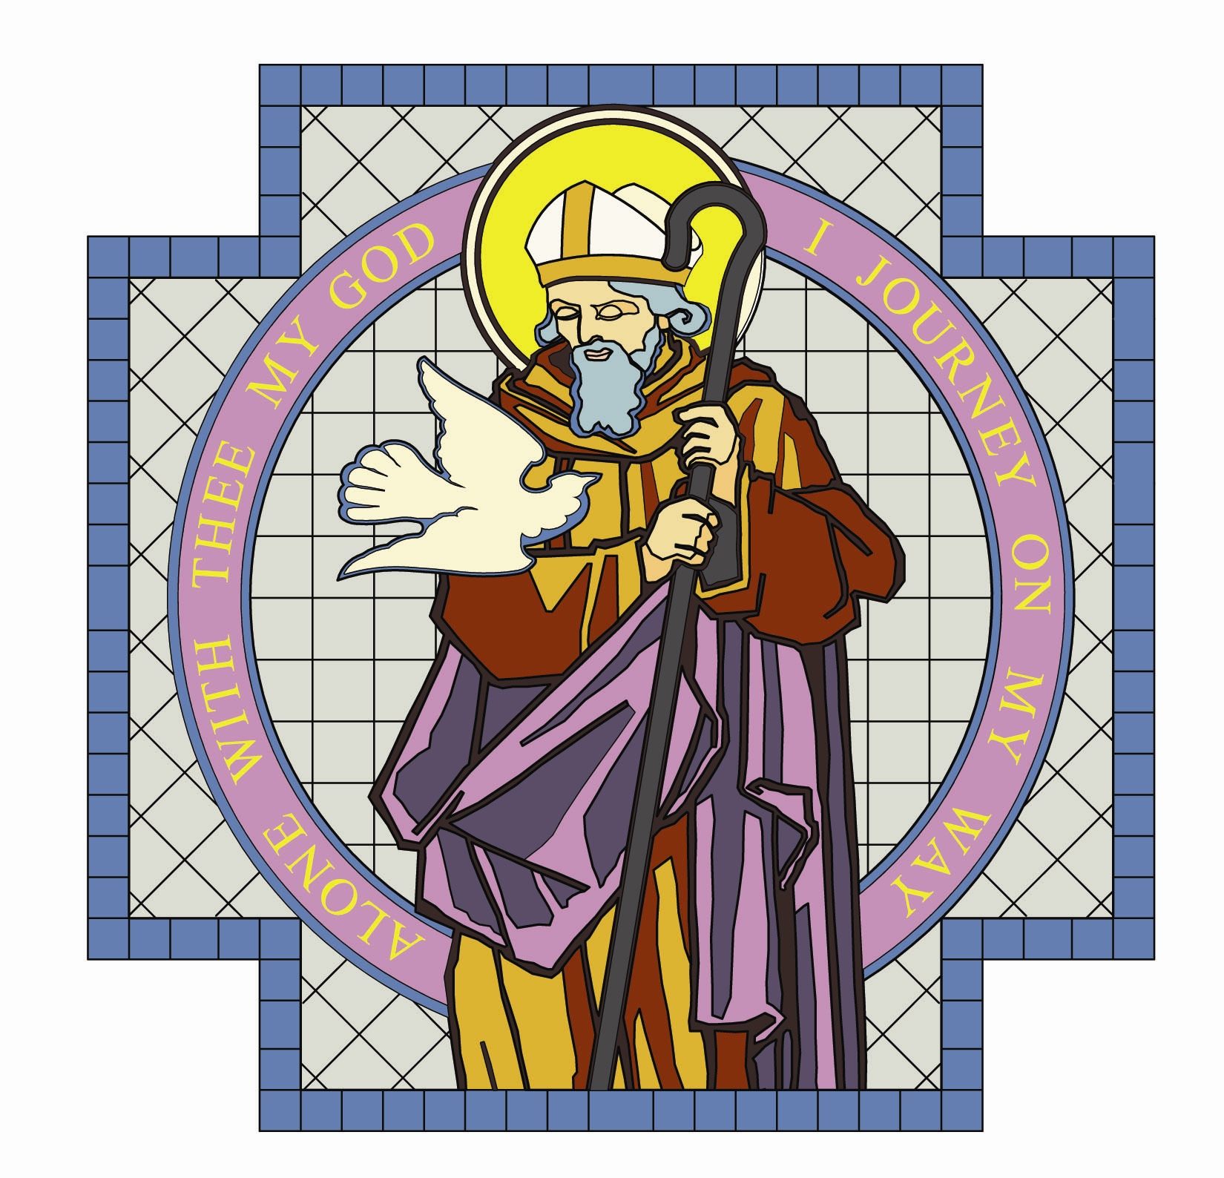

PARISH OF ST. COLMCILLE

BALLYHACKAMORE

SUNDAY BULLETIN
VOL. 28 NO. 52 13th November 2016

Fr. Ciaran Feeney Adm. 191 Upper Newtownards Road, Belfast, BT4 3JB.

Phone - 028 9065 4157. Website: www.st-colmcilles.net

E-mail - stcolmcilles@downandconnor.org

THIRTY-THIRD SUNDAY IN ORDINARY TIME (Page 960, 452, 499)
33rd Week in Ordinary Time
Readings : Sunday Cycle C, Weekday Cycle 2, Psalter Week 1

Entrance Antiphon | The Lord said: I think thoughts of peace and not of affliction. You will call upon me, and I will answer you, and I will lead back our captives from every place.
1st Reading | For you the sun of righteousness will shine out.  Malachi 3:19-20
Psalm | The Lord comes to rule the peoples with fairness.  Psalm 97
2nd Reading | Do not let anyone have food if he refuses to work.  2 Thessalonians 3:7-12
Acclamation | Alleluia, alleluia! Stay awake, praying at all times for the strength to  stand with confidence before the Son of Man. Alleluia!
Gospel | Your endurance will win you your lives.  Luke 21:5-19
Children | Jesus said that whatever disasters might happen, if we follow him faithfully he will look after us.
Communion Antiphon | To be near God is my happiness, to place my hope in God the Lord.

MASS TIMES

Saturday | Sunday | Tuesday | Wednesday | Thursday | Friday
6.30pm  Christopher Robinson | 9.30am | 9.30am  7.00pm  Mass for Deceased | 9.30am  Novena | 9.30am | 9.30am  Anointing of the sick
Confessions 6.00pm | 11.30am

